H.T No
Regulations:
A18

Sreenidhi Institute of Science and Technology
(An Autonomous Institution)
Code No: 7K404 Date: 18-Oct-2021(AN)

B.Tech II-Year II- Semester External Examination, Sept/Oct-2021 (Supplementary)
MECHANICS OF MATERIALS (CIVIL)

Time: 3 Hours Max.Marks:70

Note: a) No additional answer sheets will be provided.
b) All sub-parts of a question must be answered at one place only, otherwise it will not be valued.
c) Missing data can be assumed suitably.

ANSWER ANY 5 OUT OF 8 QUESTIONS. EACH QUESTION CARRIES 14 MARKS.

Bloom's Cognitive Levels of Learning (BCLL)

Remember | L1 | Apply | L3 | Evaluate | L5
Understand | L2 | Analyze | L4 | Create | L6

 |  |  | BCLL | CO(s) | Marks
1. |  | The stepped circular steel bar show in fig. is subjected to an axial load P of 160KN the stress in the middle portion is limited to 150MPa. Determine the diameter and the length of middle portion, if the total elongation of the bar is limited to 0.3mm. The modulus of elasticity for steel is 200GPa.  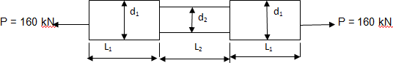  d1 =50mm, d2 =60mm, L1 = 100mm, L2 = 150mm | L3 | CO1 | [14M]
2. | a) | Explain in detail about Maximum shear stress theory. | L3 | CO2 | [7M]
 | b) | Explain in detail about Maximum principal stress theory. | L3 | CO2 | [7M]
3. |  | A simply supported beam of length 8m rests on supports 6m apart, the right hand end is overhanging by 2m. The beam carries a uniformly distributed load of 1500N/m over the entire length. Draw S.F and B.M diagrams and find the point of contra flexure, if any. | L4 | CO3 | [14M]
4. |  | Determine the forces in all the members of the truss as shown in the fig.  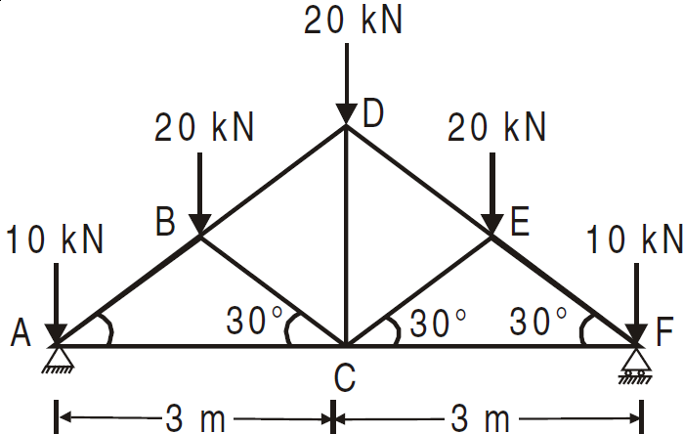 | L4 | CO4 | [14M]
5. |  | Two shafts of the same material and of same lengths are subjected to the same torque, if the first shaft is of a solid circular section and the second shaft is of hollow circular section, whose internal diameter is 0.7 times the outside diameter and the maximum shear stress developed in each shaft is the same, Compare the weights of the shafts. | L4 | CO5 | [14M]
6. |  | A rolled steel joist ISMB 300 is to be used a column of 3 meters length with both ends fixed. Find the safe axial load on the column. Take factor of safety 3, fc = 320 N/mm² and a = 1/7500 . Properties of the column section. Area = 5626 mm², I XX = 8.603 x 10⁷ mm⁴ Iyy =4.539 x 10⁷ mm⁴ | L4 | CO6 | [14M]
7. | a) | Explain the stress strain curve for a mild steel specimen. | L2 | CO1 | [5M]
 | b) | Explain in brief about stress tensor. | L2 | CO2 | [5M]
 | c) | Explain in brief about the failure criteria in beams. | L3 | CO3 | [4M]
8. | a) | Explain in detail about force deformation relationships of deformable bodies | L3 | CO4 | [5M]
 | b) | What is the ratio of torsional moments of resistance of a solid circular shaft of diameter D to that of a hallow shaft with external diameter D and internal diameter ‘d’? | L4 | CO5 | [5M]
 | c) | What are the assumptions made in Euler’s Theory. | L3 | CO6 | [4M]
-- 00 -- 00 –

